Introduction
A test model to verify and validate the new Argus3 DIM functionality has been developed. There are two versions – one to test the Simulink models that are part of the specification for the new functionality and one for testing the DIM itself. The latter includes interfacing between Matlab and CANoe to communicate with the DIM. Both models contain simulations of relevant ADAS functionality – this is based on specifications, but are by no means complete nor verified, so discrepancies are to be expected.

Structure
There is one model (DSF_A3) for testing the DIM Simulink models and one (DSF_CANoe_A3) for testing the DIM itself. The DIM models under test are referenced from the test model, so they need to be accessible in the Matlab paths, in this example they are contained in the “DIM models” folder. There are also several bus and signal definitions needed, here contained in the “Bus definitions”, “DIM datatypes” (internal signals) and “SDB datatypes” (external FlexRay signals) folders. Finally, the folder “Config” contains the model configuration, CarConfig and local configuration (LCFG) parameters for the “DSF_A3” model.
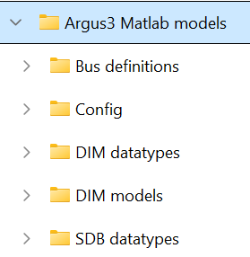
Note that changes in these are necessary to e.g. change between Argus2 and 3 or to use China or RoW functionality. Default values are for Argus 3 and RoW, by uncommenting the appropriate values on the last rows of “conf_DSF”, other settings can be applied:
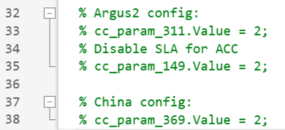

Running the test models
To initiate, it is necessary to first run (right click and select “Run” or select and push F9) the “conf_DSF” script – this will set the Matlab path and load all needed bus/datatype definitions and configuration parameters into the Matlab workspace. After this, the desired test model can be opened and run (push “Run” in the “SIMULATION” menu).
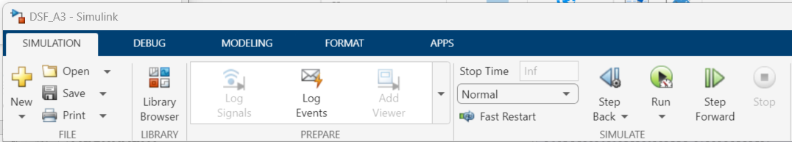

DIM model testing
For testing the DIM models, the DSF_A3 is run standalone (all applicable DIM models are referenced in the test model), and the driver interaction is made by the panels included in the test model.
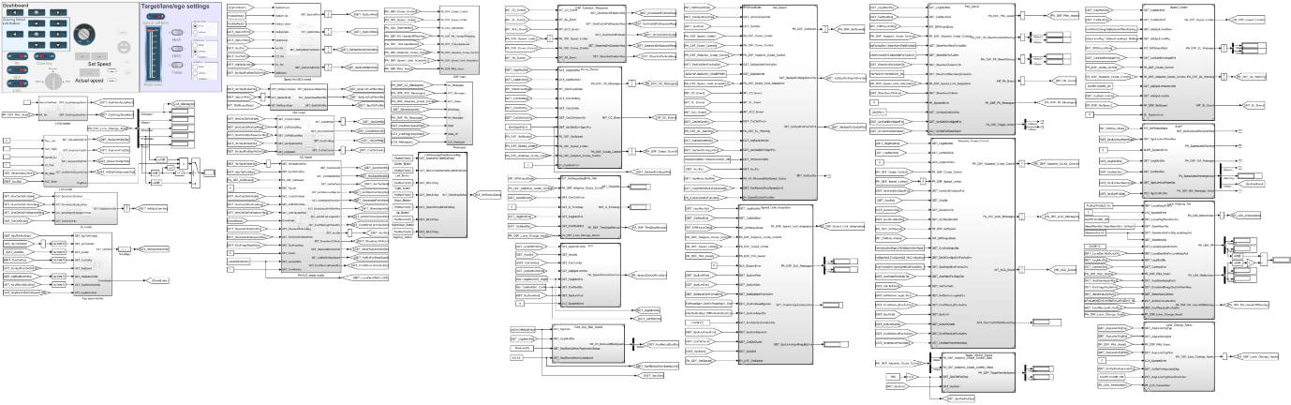
The panels also have controls for target and lane settings as well as conditions for ADAS availability:
- To the top left there are buttons for left/right indicators and abort (middle button) for testing LCA
- Below there are the steering wheel left buttons with same functionality as the real ones
- The switches at the bottom left are for turning on/off PA (preselect only), SLA, LKA and Care key
- To the right of the steering wheel buttons there is a knob for selecting CC, ACC or SL
- To the right of this there are indicators for LKA off, ACC failure and the “ADAS bubble”
- Driver acceleration and braking can be simulated by turning the knob at the mid bottom
- To the bottom right the current and upcoming speed limits can be simulated, the up/down buttons change to the next 10 km/h value
- In the right pane, target speed and lane can be changed to simulate a forward vehicle in either ego or left lane for testing ACC and undertake prevention
- To the right, there are switches and radio buttons for simulation of hands on/off wheel, DMS failure, trailer connected, LKA intervention, LCA possibility and lane visibility
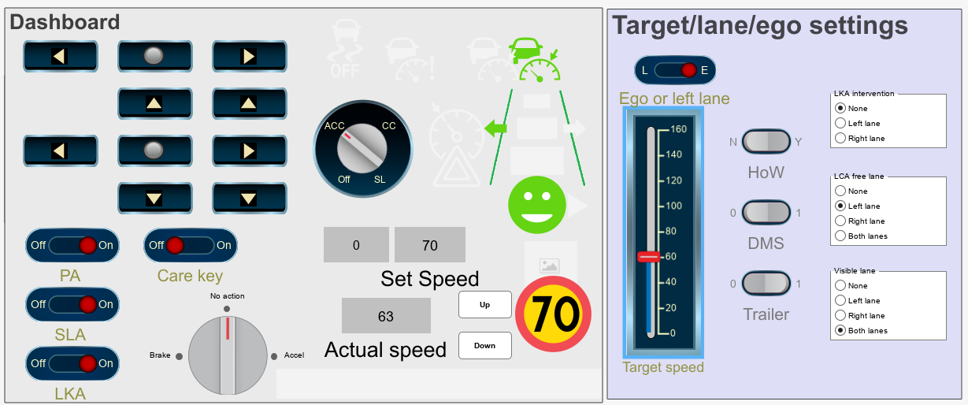

DIM testing
For testing the DIM itself, it is necessary to also start CANoe with a relevant configuration (database) and be connected to the DIM via a (FlexRay compatible) interface device. Then running the DSF_CANoe_A3 will trigger the CANoe simulation to start, and communication of the signals defined by the input/output blocks will be initiated. Note that in this case, the CarConfig parameters must be controlled via the CANoe interface directly, there is no connection from Simulink for that.
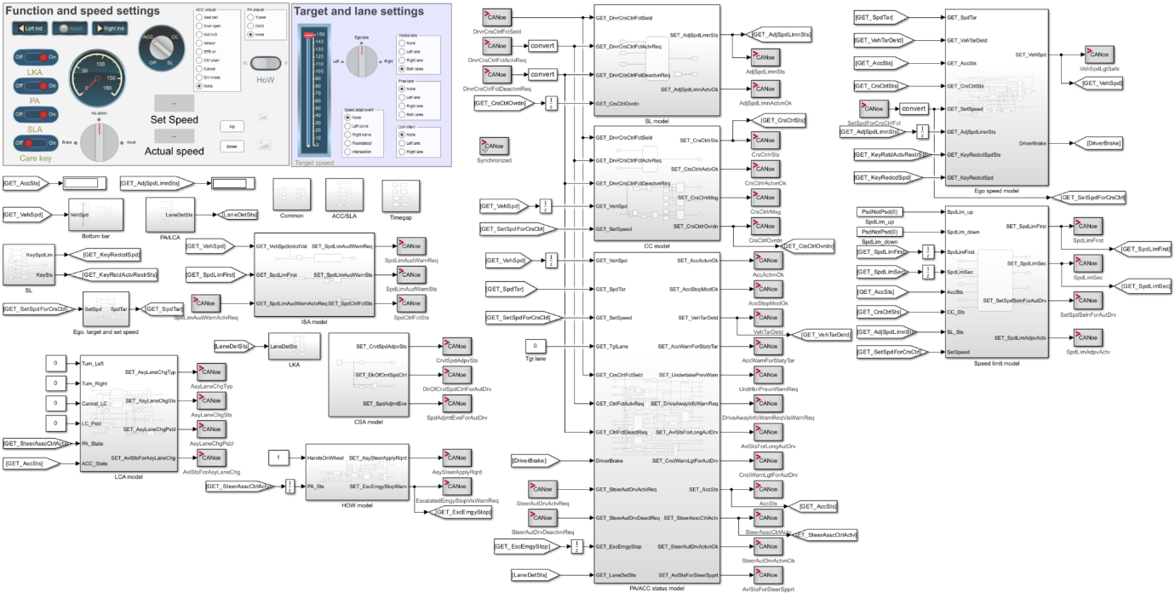
Driver interaction is performed as in “real world” via DIM and steering wheel buttons, except for acceleration, braking and indicating, which are available via test model panels (see below). The same panels for other external conditions as in DSF_A3 are also available, but with a few rearrangements and additions.
- There is a radio button panel for all ACC unavailable triggers in the left pane, to check that the respective notifications are correct
- In the right pane, there are radio buttons for simulation of speed adaption events (left/right curve, roundabout and intersection)
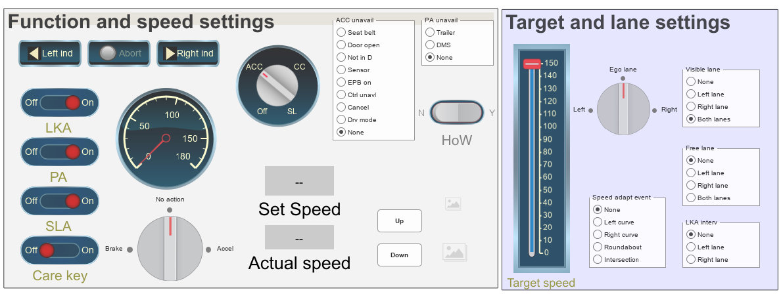
Opening the “Bottom bar” box gives access to switches and parameters for controlling the DIM bottom bar appearance.
